**Mockito**

**Exercise 1: Mocking and Stubbing**

**ExternalApi.java**

package com.example;

public interface ExternalApi {

    String getData();

}

**MyService.java**

package com.example;

public class MyService {

    private final ExternalApi externalApi;

    public MyService(ExternalApi externalApi) {

        this.externalApi = externalApi;

    }

    public String fetchData() {

        return externalApi.getData();

    }

}

**MyServiceTest.java**

package com.example;

import org.junit.Test;

import static org.junit.Assert.assertEquals;

import static org.mockito.Mockito.*;

public class MyServiceTest {

    @Test

    public void testExternalApi() {

        ExternalApi mockApi = mock(ExternalApi.class);

        when(mockApi.getData()).thenReturn("Mock Data");

        MyService service = new MyService(mockApi);

        String result = service.fetchData();

        assertEquals("Mock Data", result);

    }

}

**Output:**

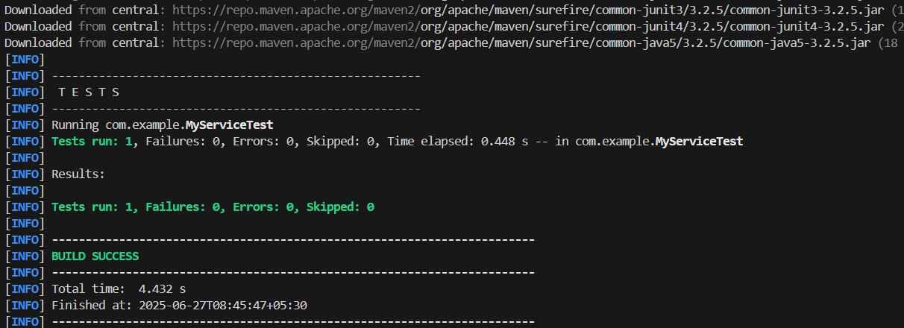

**Exercise 2: Verifying Interactions**

**ExternalApi.java**

package com.example;

public interface ExternalApi {

    String getData();

}

**MyService.java**

package com.example;

public class MyService {

    private final ExternalApi externalApi;

    public MyService(ExternalApi externalApi) {

        this.externalApi = externalApi;

    }

    public String fetchData() {

        return externalApi.getData();

    }

}

**MyServiceTest.java**

import static org.mockito.Mockito.*;

import org.junit.jupiter.api.Test;

import org.mockito.Mockito;

import com.example.ExternalApi;

import com.example.MyService;

public class MyServiceTest {

    @Test

    public void testVerifyInteraction() {

        ExternalApi mockApi = Mockito.mock(ExternalApi.class);

        MyService service = new MyService(mockApi);

        service.fetchData();

        verify(mockApi).getData();

    }

}

**Output:**

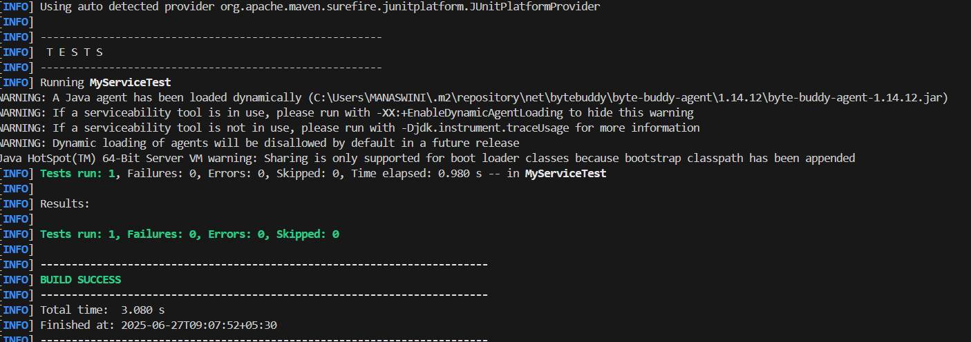

**Logging using SLF4J**

**Exercise 1: Logging Error Messages and Warning Levels**

**pom.xml**

<project xmlns="http://maven.apache.org/POM/4.0.0"

         xmlns:xsi="http://www.w3.org/2001/XMLSchema-instance"

         xsi:schemaLocation="http://maven.apache.org/POM/4.0.0

                             http://maven.apache.org/xsd/maven-4.0.0.xsd">

    <modelVersion>4.0.0</modelVersion>

    <groupId>com.example</groupId>

    <artifactId>LoggingDemo</artifactId>

    <version>1.0-SNAPSHOT</version>

   <dependencies>

    <dependency>

        <groupId>org.slf4j</groupId>

        <artifactId>slf4j-api</artifactId>

        <version>2.0.9</version>

    </dependency>

    <dependency>

        <groupId>ch.qos.logback</groupId>

        <artifactId>logback-classic</artifactId>

        <version>1.4.11</version>

    </dependency>

</dependencies>

</project>

**LoggingExample.java:**

package com.example;

import org.slf4j.Logger;

import org.slf4j.LoggerFactory;

public class LoggingExample {

    private static final Logger logger = LoggerFactory.getLogger(LoggingExample.class);

    public static void main(String[] args) {

        logger.error("This is an error message");

        logger.warn("This is a warning message");

    }

}

**Output:**

